Are You at Risk of Developing Diabetes?
Jai Medical Systems Managed Care Organization, Inc. is offering a Diabetes Prevention Program (DPP) for all qualified members at no cost for you!
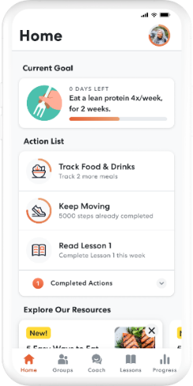
*To be eligible, you must be over 18 years old, a current member of JMS, overweight, not pregnant, have an elevated blood glucose level and never been diagnosed with type 1 or type 2 diabetes.

If you’re interested in joining an online DPP, join Omada:
- Please visit www.omadahealth.com/jaimedicalsystems
- Fill out the application
Your Jai Medical Systems member ID is needed to register, it’s located on your Jai insurance card or if you don’t know your member ID, please call us toll-free at 1-888-524-1999, Mon-Fri, 9am-6p.

Or
If you’re interested in joining in-person DPP group classes:
- Please visit www.hopkinsmedicine.org/dpep or call 410-614-2701 to find out more information
- Obtain a DPP referral from your PCP and a program coordinator will contact you!

Call our Customer Service Department at 1-888-JAI-1999 to learn more about the DPP Programs and what’s included with each program.

